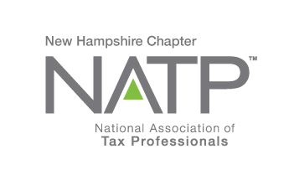
NH NATP WINTER SEMINAR

WHEN: December 6, 2019 8:30 AM to 3:30 PM
WHERE: Holiday Inn, 172 No. Main St., Concord, NH
HOW: Education Packets will be delivered electronically to all attendees registered by December 1, 2018
COST: Before December 1, 2018: Members $80 Non-Members $ 90
After December 1, 2018: Members $110 Non-Members $125
Paper Materials $25 (request when registering online)

Register online at https://natptax.com/Chapters/Pages/NewHampshireChapterEducation.aspx

By Mail: NATP, PO BOX 8002, Appleton, WI 54912

Tax Considerations when Buying or Selling a Business – Sari Ann Strasburg (2 CPE)
Sari Ann Strasburg is a speaker for NATP and a Bedford, NH attorney. She will discuss the tax consequences of buying or selling a business, and the planning opportunities it may present.

Update from the NH Department of Revenue – Peter Colbath
The ever-popular Peter Colbath will bring his wit and his wisdom and update us on the new NH business laws, and share information on the Revenue Department’s new computer system.

Solar Net Metering – Richard Labrecque (1 CPE)
Rick will focus on current net metering tariffs and the methods by which customers can sell power back to the utility. The tax implications of each will be discussed.

Web Reporting and Audit Issue from NH Department of Employment Security – Chris Lianos
Chris Lianos will speak on Web reporting for the Dept. of Employment Security, which is always an interesting topic, and this presentation promises to be informative. Audit issues are another topic that will provide useful information.

Register today!

You will want to attend this one!

