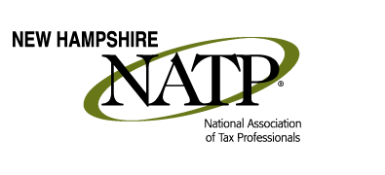
December 8, 2016 Seminar
Holiday Inn, 172 N Main St, Concord, NH

8:00 – 9:00 AM Registration and Networking
9:00 – 10:00 AM Peter Colbath, NH Department of Revenue Administration
The ever-popular Peter Colbath from the NH DRA will again bring his wit and humor to the audience as he provides the attendees with the important 2016 updates from the NH DRA.

10:05 – 11:05 AM Who’s Afraid of the Internet? Presented by Tom Strickland of Sequoia Technologies Group
Tax professionals are using computers and the internet more than ever to conduct business with their clients. The seminar will provide a practical discussion of cyber-activity threats tax professionals need to deal with, including common threats; practical, cost-effective solutions; and IRS Pub “Safeguarding Taxpayer Data”.

11:15 AM – 12:05 PM Tax Issues for Seniors, presented by Sol Asmar, Susan Paul and Lynn Annicchiarico (4 CPE)
Most likely every tax professional has clients who are elderly taxpayers. Preparing a senior’s tax return is just as important as preparing any other taxpayer’s return. This course helps conquer the struggles of completing an elderly taxpayer’s individual income tax return and insure nothing is forgotten. At the end of this course, you will be able to calculate lump-sum distributions, including the possibility of 10-year-averaging; evaluate any credits and deductions that are available to elderly taxpayers; report long-term care expenses and insurance proceeds; differentiate between taxable and non-taxable income; and solve unique circumstances when receiving social security benefits.

12:05 – 12:50 PM Lunch and Networking

12:50 – 2:30 PM Tax Issues for Seniors – continued

2:30 – 2:40 PM Break

2:40 – 3:30 PM Tax Issues for Seniors – continued

Early Registration until 12/02/16: Members $85 Non-Members $95
After 12/02/16 Members $105 Non-Members $115

Register online at www.natptax.com/Chapters/Pages/NewHampshireChapterEducation.aspx

Seminar materials will be delivered electronically a couple of days before the seminar. WiFi is available. Please inform us before the seminar if you would like a printed copy of the seminar materials, which is available for an additional fee. Contact sperry@mdccpas.com.

SAVE THESE DATES FOR FUTURE SEMINARS
2017 - NH Chapter May 25th October 26th December 7th all in Concord, NH
2017 – NATP National Convention Aug 7-10 – Washington, DC

