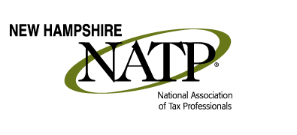
___________________________________________________________________
EDUCATION SEMINAR

MAY 21, 2015

Holiday Inn
172 N Main Street
Concord, NH

8:30 AM - Registration

9:00 AM - 2:00 PM - Passive Activity from Theory to Practice - 4 CPE - (regular break and lunch break included in this time frame)
Passive activity is growing in importance since the birth of Net Investment Income Tax. From renting a vacation property to partnership involvement, this hands-on, step-by-step seminar is a must for many.

2:00 PM - 4:00 PM - Representing Today's Client - 2 CPE
A hands-on, real-life seminar examining the issues facing tax professionals today. From recordkeeping to reconstruction, case building to appeals.

Our Speaker
Kathryn Keane, one of our most popular speakers, returns to New Hampshire to do this education seminar for us. Her credentials include:
* Served on the Board of Directors of NATP for 6 years
* Awarded the 2002 NATP Chapter Person of the Year
* Also a member of NSA, IAA of Brooklyn and NAEA
* Serves on the Liaison Committee of the IRS
* Immediate Past President of the NY Chapter of NATP
* Appeared on PBS's Newshour with Jim Lehrer, as well as WCBS News
* Her articles frequently appear in Tax Pro Monthly and the Independent Accountant
* Featured heavily in March 2006 NY Post article on tax refunds and withholding
* Widely sought after speaker on tax topics throughout the profession

Sign up today at http://www.natptax.com/Chapters/Pages/NewHampshireChapterEducation.aspx
Share this info with your colleagues! This is going to be a good one!

