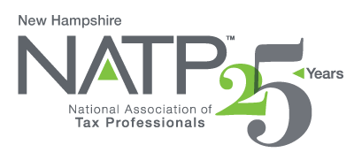
NH NATP SEMINAR

May 25, 2022

8:30 AM to 4:10 PM

Holiday Inn, 172 No. Main St., Concord, NH 03301

Randy Lawshé is an Enrolled Agent (EA) who holds a B.A. degree in management and an M.B.A. degree with a concentration in marketing and finance from Southeastern Louisiana University and will be the presenter for the day.

TOPICS:

Estates and Trusts – Discuss of the various types of estates and trusts and define the benefit of using each of these tools. Identify filing requirements for forms 706 and 709.

Comparing S-Corps & Partnerships – Provide basic knowledge regarding the main differences between the two. Discuss the tax advantages of each.

Virtual Currency – Become savvy with the tax issues and consideration in respect to virtual currency. The latest IRS guidelines will be presented as well as examination of common types of clients, how to work with them, and how to limit liability.

Ethics – Review of selected provisions of Circular 230 applicable to tax return preparation and practice before the IRS.

FEES: Early Standard
Member $180.00 $220.00
Non-Member $200.00 $260.00
Last Day Offered 5/16/22

Seminars materials will be emailed prior to seminar. Fee for printed materials is $35.00available at check-in.

Lunch will be provided.

Register online at https://natptax.com/Chapters/Pages/NewHampshireChapterEducation.aspx

By Mail: NATP, PO BOX 8002, Appleton, WI 54912

We hope to see you there!

