Y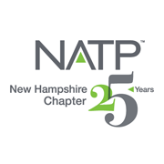 |  | - Upcoming Seminars  May 21, 2020  Oct. 22, 2020  Dec. 3, 2020
NATP – the organization for tax professionals WEBSITE: natptax.com |  | NH Website: NHNATP.com

Keep up to date on the happenings of our Chapter by visiting these websites and Facebook frequently:
www.natptax.com www.nhnatp.com
This Photo by Unknown Author is licensed under CC BY-SA
This Photo by Unknown Author is licensed under CC BY-NC-ND
A Letter From our Outgoing President
It is hard to believe we are approaching the end of another year and are already getting snow tires put on, searching for our gloves and all the other tasks that go along with preparing for a long New England winter. As I write this my admin is busy getting us prepared for the other season that goes along with winter – “tax season” and she is ordering the folders, the paper, the ink and all the other sundry supplies needed to stock our office.
I found this past tax season a particularly difficult one – the changes from the Tax Cuts and Job’s Act, the new design of the 1040 and clients whose lives are so busy that they seemed more disorganized than usual. I am optimistically preparing for this next tax season and hoping it will be one with less chaos and fewer extensions!
NATP is a great resource for us as we prepare for another tax season and we can sharpen our brains by attending the 1040 Workshop which will be put on by our national organization in Concord, NH on November 20 and 21. We also have our Winter Chapter event on December 5 – we will have presentations from NH and ME Department of Revenue presenters, a presentation on charitable giving and John Cunningham will speak to us on Sec 199A and how it is treated for various entities. In addition to the education you will also have the opportunity to network with colleagues.

NH NATP has two board members whose terms are expiring November 30th and they have chosen not to rerun. Shirley Perry and Stephanie Sinclair have been the team to welcome you as you sign for seminars for several years and have done a great job behind the scenes of making sure all paperwork is submitted to obtain your CEs. They will be missed, and I want to extend to them a huge “thank you” for all they have done.
Harold Williams has resigned from the board for personal reasons and the balance of his term will be served out by our former President Lynn Annicchiarico. Thank you to Harold for all he has done for NH NATP.
This is my last article as the President of the NH Chapter, and on December 1st I will be handing over the reins to Betsy Bowen who I know will do a great job of leading the Chapter and continuing to provide us all with great education and resources. I would like to thank everyone who have served with me on the board over the last three years – it was a pleasure to be part of such a great team. I will be continuing to serve on the board and look forward to working with all the returning board members and two new board members Ed Condict and John Preve.
I hope you all have a good Thanksgiving and my best wishes to each of you for a successful and prosperous tax season.
Carol Romeril
NH NATP President
===============================================================================
This Photo by Unknown Author is licensed under CC BY-SA
Officers and Directors elected at the October 24, 2019 Annual Meeting for the 2019-2020 year:

OFFICERS
President Betsey Bowen, EA
Vice President Susan Paul, EA
Treasurer Chris Sawyer, EA
Secretary Norma Boyce, EA
DIRECTORS
Kimberly Perkins, EA Dale Harrington, EA
Anna House, EA Ed Condict, EA
John Preve
PAST PRESIDENTS (ADVISORS)
Lynn Annicchiarico Carol Romeril

Feel free, at any time, to approach any one of these individuals with your questions or comments. We serve for you!

Review of our October 24, 2019 Seminar
(Submitted by John Preve)
On Thursday, October 24, our NH Chapter had a full day seminar presentation at the Holiday Inn, in Concord. The event was well attended, and the presenters were extremely knowledgeable in their subject matter. They covered a lot of material and kept the sessions moving along at a good pace.
Our first presenter was Joe McCarthy, IRS Senior Stakeholder Liaison, who gave us a very informative presentation on internet security and what we can do to better protect our system, and our clients, from internet hacks. Joe reminded us of our need to be careful that we do not sacrifice security for convenience.
He gave us six protections that we should consider implementing to better safeguard us from hacks. The six protections are: anti-virus software, firewalls, two-factor authentication, backup software/services, drive encryption, and virtual private network (VPN). He went to considerable lengths to explain to us what each of these protections can do for our internet safety and to see if they make sense for our individual practices. He recommended that we review the IRS Publication 4557 titled “Safeguarding Taxpayer Data” for further tips on how bring these protections into reality.
Joe also recommended that we check with our professional insurance policy to see if we have any coverage for data thefts. He reminded us of our requirement under federal law to have a security data plan in place with steps of what we would do in the event of our system being hacked and data compromised. We need to be very careful and vigilant to ensure our staff does not click onto unfamiliar emails or fake websites which are invitations for “very bad” people to help themselves to our hard drives and potentially holding us hostage to regain access to our data.
Finally, do not forget, one of the simplest things we can do to help protect our data is to have strong passwords and change them frequently. Remember, do not sacrifice safety for convenience.
Our last presenter was Helen O’Planick, EA, who has her own tax preparation practice in PA. She was a presenter for us last year too. Helen is very knowledgeable of the tax code and income tax preparation. She presents well and has a quick wit about her which makes listening to her very enjoyable.
Helen had four different segments covering US Savings Bonds, our growing gig economy, tax savings for our clients, and, everybody’s favorite topic, depreciation.
Regarding savings bonds, she reminded us that they are a “great gift for newborns because one size fits all and the bonds grow in value as the child grows”. They are a very safe resource for our savings with the series I bonds adjusting its rate of interest twice per year to keep up with the rate of inflation. The current interest rate is 2.83%. For more information check out the bond website treasurydirect.gov.
Her next topic, the gig economy, is defined as “a labor market characterized by the prevalence of short-term contracts or freelance work as opposed to permanent jobs. It is not confined to any specific industry, culture, socio-economic factors or geographical region. It provides temporary work and additional income.” With such a broad range of potential gig opportunities, she stressed that taxpayers will need our guidance as to what is taxable income and allowed expenses for their particular gig. It is a substantial area of growth in the US economy and we would do well to be prepared to ensure our clients are reporting their activity on the correct tax forms.
When Helen covered depreciation, she did a really good job covering the pluses and minuses of depreciation and when a client may desire to “take all they can get” with section 179 or bonus depreciation or when it might be more beneficial to stretch depreciation out over years if a client believes their business income might be greater in future years. She gave some great definitions of depreciation and the rules governing the type and amounts of depreciation a taxpayer can take. She titled this part of her presentation “fun and games with depreciation”. Her slides on this topic are most definitely worth the review.
Helen finished her presentation with “covering tax savings for our clients”. She stressed how we would serve our clients well by reminding them of company retirement plans and flex spending accounts if offered by their employer. Lots of workers with eligible health insurance plans now qualify for health savings accounts. These are great accounts and the money contributed to them do not follow the “spend it or lose it” rule. Many local banks offer health savings accounts helping taxpayers to keep their money local. She ended this segment covering the different ways taxpayers may be able to reduce their tax liability, in light of the higher standard deduction, by properly reporting deductions on other various forms. Once again, reviewing the slides of this presentation could give us some great ideas in helping our clients.
In conclusion, I find these local seminars very beneficial to my practice. The members of our local chapter deserve great appreciation for their hard work in bringing such experienced presenters to our NH Chapter. At the noon hour, we celebrated the 25th anniversary of our chapter with cake for all and applause for the folks who work to lead our organization and contribute much to its success. Here’s to many more years to come.
* * * * *
The Annual Meeting of the NH Chapter of NATP also took place on October 24, 2019. Melissa Bowman from National also spoke to us about the advantages of membership and what NATP was doing and what they had planned for the future.
The highlight was the observation of the 25th Anniversary of the NH Chapter. Yes, 25 years!
Al Columb and Ed Zelazo were founding members of NH NATP Chapter 25 years ago. They were in attendance and were recognized by their fellow tax professionals.
It was a very proud event for tour chapter.
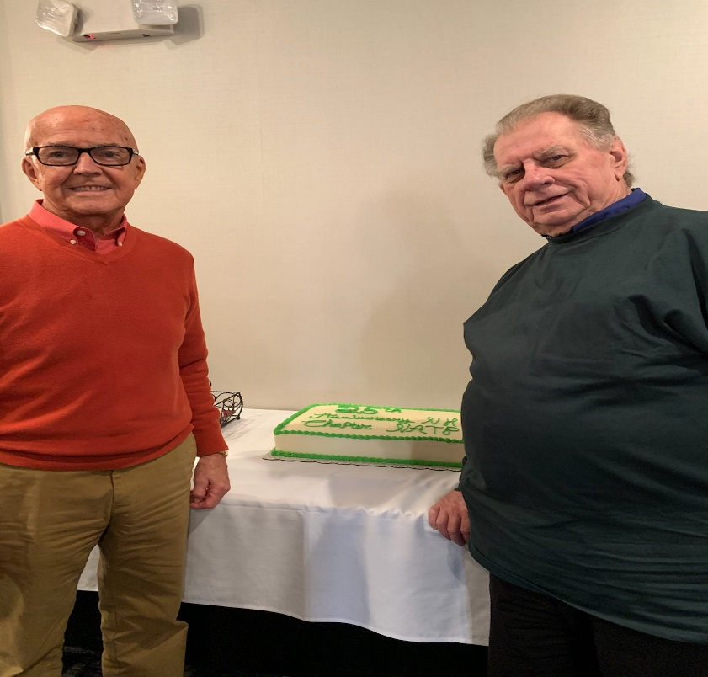
l. Al Columb, r. Ed Zelazo

And, of course, there was a cake!
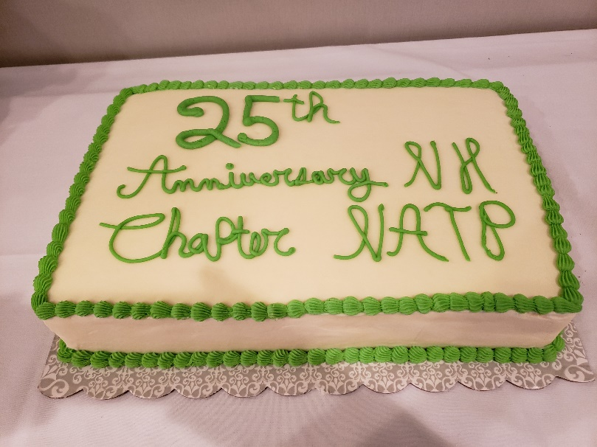

National sent $250 to the NH Chapter because of the 25th Anniversary, and it was used for the cake and door prizes.
Winners of the Door Prizes
$25 Staples Card
Mary Doane
Bernadette Kaszynski
James Valz
Al Columb

$25 Dunkins Card
Theresa Matthews-Bolen
Paul Bouchard
William Shee

Free NH NATP Seminar

Diane Ventresca
Ralph Renzelman
=====================================
BITS and PIECES
New Form 1040-SR: This new form can be used only by individuals who are 65 or older. However, it is not required. The IRS projects that some 1.8 million paper returns and 17 million e-filed 1040-SRs will be filed it the form’s first year.
NEW Schedules: Starting with the 2020 filing season, Schedules 2 and 4 will be consolidated into one, as will Schedules 3 and 5. Schedule 6 will be eliminated.
E-Filing Growth: Since the IRS Restructuring and Reform Act of 1998, the number of individual returns e-filed increased from 24.6 million in calendar year 1998 to 134.7 million in 2018. IRS expects to hit 137.2 million e-filed returns in 2019, and 152.4 million in 2026.
Impact of TCJA: As a result of the increased standard deduction, Schedule A volumes are estimated to decrease in 2019 almost 65% from 2018. More balance due returns are expected in 2019, with refund volumes projected to decrease by some 2% from CY2018.
SALT: On October 28, 2019, the Senate rejected Democrats’ efforts to repeal the SALT (State and Local Taxes) deduction rules by a 43-52 vote. The deduction had been especially valuable to the taxpayers in New York, New Jersey and California.
Tax Credits: IR-2019-18 recommended that taxpayers (and tax preparers) take time now to determine the eligibility for important tax credits – Earned Income, Child, Other Dependents and Education. IRS’ Interactive Tax Assistant (ITA) can help to determine eligibility, and to also provide answers to general questions. The IRS recently updated its Get Ready page with steps to follow now for the 2020 filing season.
The Tale of the Dead-Broke Business Owner:
At his peak, taxpayer “Jerry” had a successful consulting business. That company was his first success after a string of business failures. After many years of struggle, “Jerry” was finally living it up. He liked to live well, so he bought a beautiful home in the mountains. He spent every cent his business took in on cars, artwork, travel, fine dining and living the good life.
Except he forgot one teensy detail: taxes!
Somehow, he neglected to pay taxes for 3 or 4 years. He had filed returns on time, but he hadn’t paid what he owed. A tax professional got him set up with an installment agreement and admonished him to find ways to cut his spending and set something aside for his retirement, which was now only a few years away.
All went well for 2 years. He was keeping up with his payments, and, slowly, his mountain of tax debt was getting whittled down. He was even saving a bit of money.
Then “Jerry’s” health failed. Suddenly, he couldn’t work anymore. It turned out he had massively overextended himself. Bit by bit, over several years, his world fell apart. His collection of high-end sports cars was repossessed or sold. His lovely mountain home went into foreclosure. He sold everything he could. He moved into a tiny apartment in a seedy part of town.
He signed up for Social Security as soon as he could, but his uneven work history meant his check wasn’t much. Even at that, the IRS started garnishing his Social Security benefit checks.
An Offer in Compromise was prepared, but he waited until the oldest debt dropped off. The amount that “Jerry” could pay was just a drop in the bucket toward the nearly $100,000 he still owed. Unsurprisingly, IRS rejected his offer. They did the math, and they knew they were coming out ahead by continuing to garnish his Social Security.
Sometimes taxpayers, our clients, cannot be saved from themselves!

NH DRA Press Release November 4, 2019:
The NH DRA has launched the first of 3 phases of its new online user portal and revenue management system, overhauling decades old technology and providing taxpayers an improved online experience. NHDRA, which collects more than $2 billion in taxes each year, expects the full implementation for all tax types to be complete by the end of 2021.
The new Revenue Information Management System (RIMS) and Granite Tax Connect (GTC, its online user portal, launched October 28, 2019 for more than 9,000 taxpayers, including those who pay Meals and Rentals, Nursing Facility Quality Assessment and Medicaid Enhancement Taxes. Granite Connect allows taxpayers, operators and practitioners to complete tasks online, such as file taxes electronically, schedule automated payments, view correspondence from NHDRA, check on the status of returns, payments, web requests, and more.
The launch of RIMS and GTC have been in the works for nearly 4 years, and this is NHDRA’s largest technology update since their previous system was launched nearly 30 years ago.
NHDRA has been working diligently to prepare for this 1st phase of the rollout, communicating updates to taxpayers of all types, creating a dedicated webpage with GTC resources and conducting in-person demonstrations.
Peter Colbath is more than likely to give us more details on December 5, 2019 when he addresses the attendees of the NH NATP Winter Seminar.
Phase 2, the largest rollout, expected in the fall of 2020 will include BET, BPT, I&D, and
Communications Tax, approximately 139,000 taxpayers.
Facebook Groups of interest to Tax Preparers:
At the October 24, 2019 Seminar and Annual Meeting, our National Rep Melissa Bowman and our seminar instructor Helen O’Planick put their heads together and came up with a list of Facebook Groups that might interest tax preparers. Helen had previously expounded on the helpfulness of Facebook Groups, and encouraged the attendees to “check it out”.
The next page lists some of these groups.

The Officers and Directors of the NH Chapter of NATP cordially wish you and your family a very happy holiday season.

Facebook Groups of Interest:
Tax Professionals of America https://www.facebook.com/groups/TaxProOfAmerica/
Accounting and US Tax Compliance https://www.facebook.com/groups/WAHMtaxgroup/?ref=br_rs
Enrolled Agents – The Tax Professionals https://www.facebook.com/groups/WeSpeakTax/
Small Business Tax Assistance https://www.facebook.com/groups/1588422751264960/
Tax and Acctg. Practice Mgmt. https://www.facebook.com/groups/1424243784534391/
Tax Ink Tax 101 https://www.facebook.com/groups/1536126986706307/
Tax Preparers Stress Relief https://www.facebook.com/groups/taxprepventing/
The Sisterhood of Lady Tax Pros https://www.facebook.com//groups/564984696972979/
Representation Forum https://www.facebook.com/groups/579166708876217/
Sch E Rentals & Real Estate Taxation https://www.facebook.com/groups/142653696688372/
Compass Tax Educators Network https://www.facebook.com/groups/569796436731079/
IRC 199a: Law, planning & Analysis https://www.facebook.com/groups/276143163090468/
US Tax Pros https://www.facebook.com/groups/USTaxPros/
Cyber Security for Tax Pros https://www.facebook.com/goups/CS4taxpros/
ACA Tax Pro Q&A https://www.facebook.com/groups/1520722844867825/
Ask Sheeley https://www.facebook.com/groups/229354164157811/
Form 3115 Facebook Group https://www.facebook.com/groups/957686720909103/
Tax Preparers Support Group https://www.facebook.com/groups/taxpreparerssupportgroup/

The complete url addresses are listed above to assist you in connecting with the Facebook Groups. If you should experience difficulty with any one that you try to access, please contact your co-editor at NBoyce33@gmail.com, and I will do my best to help you. Please include your phone number and best time to contact you in the email. =============================================================================== DON’T,
DO NOT,
FORGET ABOUT THE UPCOMING DECEMBER 5TH SEMINAR. REVIEW THE ANNOUNCEMENT ON THE FOLLOWING PAGE, AND THEN REGISTER.

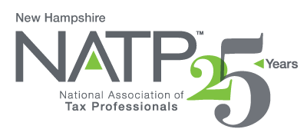
NH NATP WINTER SEMINAR

WHEN: December 5, 2019 8:00 AM to 4:05 PM
WHERE: Holiday Inn, 172 No. Main St., Concord, NH
HOW: Education Packets will be delivered electronically to all attendees registered by December 3, 2019
COST: Before November 29, 2019: Members $100 Non-Members $110
After November 29, 2019: Members $130 Non-Members $145
Paper Materials $25 (request when registering online)

5 CPE hours

Register online at https://natptax.com/Chapters/Pages/NewHampshireChapterEducation.aspx

By Mail: NATP, PO BOX 8002, Appleton, WI 54912

NH Department of Revenue – Peter Colbath, M.S., Tax Auditor, State of NH, Dept. of Revenue
Department of Revenue Updates
Review of Common Errors
Q & A Session

Maine Revenue Services – Jeffrey Bragdon, Tax Section Manager, State of Maine Tax Services
Maine Tax Law Updates
Common Errors on Non-Resident Returns
Q& A Session

NH Charitable Foundation – Richard Peck, VP of Development and Philanthropy Services
Charitable giving solutions that can be used to offer maximum tax benefits
Charitable IRA Rollovers
Triggering events, like stock options, conversions of traditional IRAs to Roth IRAs

Partnerships and Single Member LLCs and Section 199A – John Cunningham, Counsel to McLane Middleton, P.A.

Federal taxation of single member and multi member LLCs
Overview of passthrough deductions under Section 199A
Introductions to key issues under Section 199A
When business owners need Section 199A restructuring
How to develop a Section 199A restructuring plan

REGISTER TODAY! THIS WILL BE ANOTHER GREAT SEMINAR!

===============================================================================

Just one last bit of information. The 2019 Form 1040 will be two pages again. Yes, it has been updated!
Check it out at IRS Draft Tax Forms – https://www.apps.irs.gov/app/picklist/list/draftTaxForms.html.

We hope you have enjoyed this Newsletter.

Your co-editors,
Kim Perkins, EA and Norma Boyce, EA

The End

