Y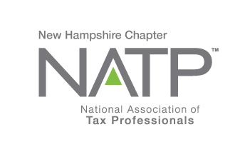 |  | - Upcoming Seminars  Oct. 25, 2018  Dec. 6, 2018
NATP – the organization for tax professionals WEBSITE: natptax.com |  | NH Website: NHNATP.com

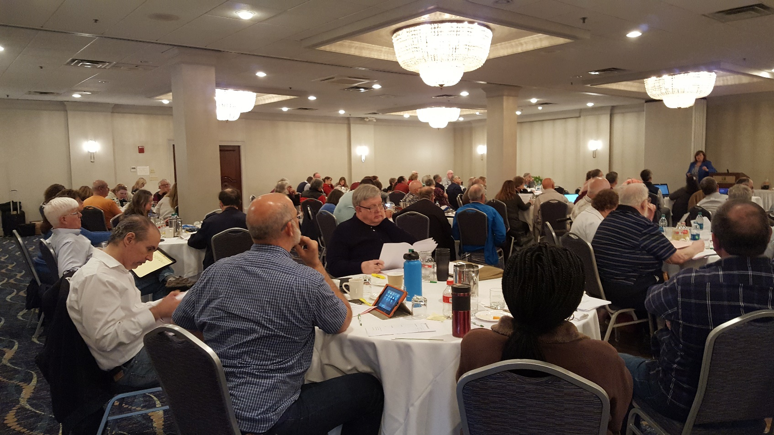
WOW! This May 24th seminar with the Mellems was a great one! Mary Mellem is at the podium in the background addressing your fellow members with the latest tax information she had.
When David and Mary Mellem each started their presentation on the topic of Federal Tax Update, the ballroom at the Holiday Inn in Concord, NH fell so quiet you could hear a pin drop! Nary a participant at the May 24th seminar wanted to miss a single word! To use an old cliché, everyone was “all ears”! And rightfully so! To have the highly qualified duo, known as the Mellems, present such a timely subject was the best of both worlds – new laws, and presented in a manner, with examples, that could be understood by all. Whether we like the law or not, the Mellems brought many of the details to our doorsteps. They also presented Ethics, Like Kind Exchanges and Life & Remainder Interest Issues with the same volume of energy, but somehow those topics took “second fiddle” to the new tax laws. The Mellems are wonderful people and great teachers and we hope to have them again at any upcoming seminar. If you missed this seminar, I feel bad for you because it was a GREAT ONE!!!
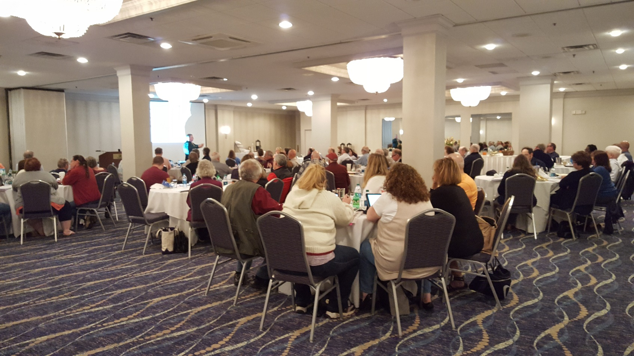
DAVID MELLEM (standing, in the background) provided the participants with meaningful examples applied to the new tax law. He even made the audience laugh now and then!
___________________________________________________________________________________________________

The NH NATP Chapter now has a Facebook Group page. Go to NH NATP on Facebook and LIKE us. Join in the conversations, share information, vent a little, report breaking news, or just say “hi” once in a while.
______________________________________________________________________________________________________________________________
AND, don’t forget the NH NATP Website! Another place for you to go to find valuable information. WWW.NHNATP.COM. And remember, you can always contact an Officer or Director of NH NATP with your concerns or questions.
_____________________________________________________________________________________________________________________________
A good line for next year…… Everything we own is taxed – even our patience.

IRS unveils new EA logo
The IRS has released a new Enrolled Agent logo that EAs may use in marketing materials. It replaces a logo that the IRS created in 2012.
While use of the new logo is optional, the agency said, use of the prior logo must cease. One reason: The prior logo contains a likeness of a government insignia, which the IRS said legally limits its use to officers and employees of federal departments and agencies.
EAs have until October 31 to discontinue use of the logo containing the IRS eagle.
“We apologize for this error and any confusion that we may have caused,” the agency said in an announcement.
Active enrolled agents can obtain the logo by emailing a request to epp@irs.gov with the subject line “EA logo."
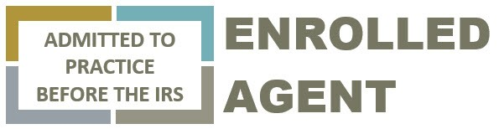
The new EA logo – May 15, 2018 – TaxPro Today, reprinted with permission

A professional tax preparer is having a hard time sleeping and goes to his doctor. “Doctor, I just can’t get to sleep at night”. “Have you tried counting sheep?”, the doctor asks. ‘That’s the problem” replies the professional tax preparer “I made a mistake and then spent three hours trying to find it”.
_________________________________________________________________________________________________
Taxpayers Who Will Benefit from Tax Reform
Infrastructures/Fixed Assets
Corporations
Pass-through Entities
Taxpayers Who Will Be Negatively Affected by Tax Reform
Professional Athletes
Small Wage Contractors
Entertaining Taxpayers
(With Permission, CPA Tax and Compliance Advisor, May 25, 2018)

And, Do You Agree With This?
According to Mary Cole, Editor of Checkpoint Learning Products with The Thompson Reuters Tax & Accounting Business, on May 3, 2018 in the Accountant’s Daily News by Accountant’s World.
The 3 Most Important Things to Know About the Tax Cuts and Jobs Act ……..
- Tax Rates, Standard Deductions, and Personal Exemptions
- Itemized Deduction
- Alternative Minimum Tax

___________________________________________________________________________________________________

From Chris Sargent, Treasurer of NH NATP:

You play an important role in the nation’s tax system by helping taxpayers file their returns and meet their tax obligations. To ensure paid tax return preparers are following the law, we want to highlight some potential penalties with respect to preparation of clients’ tax returns. The goal of this campaign entitled “Did You Know” is to make sure you’re not engaging in return preparation practices that may subject you to a preparer penalty.

Preparer Penalty Awareness: IRC 6695(a) Failure to Furnish Copy to Taxpayer
Did You Know? Internal Revenue Code, Section 6107(a) requires all paid tax preparers to furnish the taxpayer with a completed copy of their tax return before (or at the same time) the return is presented to the taxpayer for signature. Failure to comply with this law may subject you to an Internal Revenue Code, Section 6695(a) penalty of $50 per occurrence with a maximum assessment of $25,500 in any calendar year. You may provide the taxpayer a copy in any acceptable media, including electronic. It must include all information submitted to the IRS, except it isn’t required to contain your Preparer Tax Identification Number (PTIN).
For more information on Preparer Penalties visit: www.irs.gov/tax-professionals/summary-of-preparer-penalties-under-title-26

Preparer Penalty Awareness: IRC 6695(b) Failure to Sign Return
Did You Know? Paid tax preparers are required to identify themselves in the Paid Preparer Use Only area near the signature section of the return. Return preparers who fail to sign returns may be subject to an Internal Revenue Code, Section 6695(b) penalty of $50 for each failure to sign with a maximum penalty of $25,500 in any calendar yea

Preparer Penalty Awareness: IRC 6695(c) Failure to Furnish Identifying Number
Did You Know? Internal Revenue Code, Section 6109(a)(4) requires paid tax return preparers to include an identifying number along with their name when signing the return. IRS regulations require the identifying number be a Preparer Tax Identification Number (PTIN). Failure to provide a PTIN may result in an Internal Revenue Code, Section 6695(c) penalty of $50 for each failure with a maximum penalty of $25,500 in any calendar year.

Preparer Penalty Awareness: IRC 6695(d) Failure to Retain Copy or List
Did You Know? Internal Revenue Code, Section 6107(b) requires tax return preparers to:
a. Retain a completed copy of all returns prepared or a list containing the names, taxpayer identification numbers, tax years, and types of all returns prepared, and
b. Make such records available for inspection upon request by the IRS for a three-year period
For each failure to comply, you could be subject to an Internal Revenue Code Section 6695(d) penalty of $50 with a maximum penalty of $25,500 per year.

Preparer Penalty Awareness: IRC 6695 (f) Negotiation of Check
Did You Know? Paid tax professionals aren’t permitted to endorse or otherwise negotiate a refund check issued to a taxpayer. This is true, even if the taxpayer requests their refund be directed into your bank account or in your name. Failure to comply could result in an Internal Revenue Code, Section 6695(f) penalty of $510 for each tax return with no maximum penalty amount and no reasonable cause exceptions.

______________________________________________________________________

The facts, just the facts, please,

Results from the participant evaluations for the May 24, 2018 seminar:
(On a scale of 1 to 5, with 5 being excellent)
Like-Kind Exchanges 4 and 5 combined, 95.945%
Ethics 4 and 5 combined 93.045%
Federal Tax Update 4 and 5 combined 94.410%
Life and Remainder Trust 4 and 5 combined 91.156%

Garnering the most low-rated votes (1-3) was “Was the Time Allotted to Learning Adequate?”.
Like-Kind Exchanges 4 votes 5.541%
Ethics 8 votes 10.526%
Federal Tax Update 13 votes 18.571%
Life and Remainder Trust 15 votes 23.809%
(Let’s face it people, the Mellems could have held a week-long seminar, and we would have still wanted more! Ed)
A few people also rated the facilities/equipment adequacy and audio and video satisfaction with low numbers.
Just as a side note, if there is something happening at the seminars that bothers you, please bring it up to a Board member. While we can’t be perfect, the Education Committee tries very hard to make your education experience as effective as possible.
___________________________________________________________________________________________________

Do you think we will all look back at the 2017 tax year with nostalgia? Like “back when” or “the good old days”.

Carol’s Comments – A message from our President

We made it through another tax season and I hope by now you have all caught up on your rest and have been able to spend some quality time with family. If you filed extensions for some of your clients you may now be regrouping and getting ready to tackle those returns. For all of us our time in the office this off season might be a little more than usual as we become more familiar with the Tax Cuts and Jobs Act and start to consider how this impacts our clients. I anticipate my calendar for later this summer will start to fill up with tax planning appointments as I educate my clients on what the changes mean to them.

I am so grateful that I have the resources of NATP available to provide me with the education I need to understand this new legislation and to let me be the tax professional that my clients depend on. The education began at the NH Chapter’s Spring Seminar with a session from David & Mary Mellem on the tax changes – it was good to see so many of you there.

I will be continuing my education in August when I head to NATP’s National Conference in Anaheim California. I am looking forward to four days packed with great education from some of the best instructors in the profession. If you are planning to attend National Conference send me an e-mail and hopefully all who are there from NH can meet for dinner one evening.

Education will continue in October when national presenter Jaye Tritz comes to NH for our Fall Seminar on October 25th. We will have another education opportunity November 28 & 29 when the 1040 Workshop comes to Concord NH.

If in-person education does not work for your schedule I encourage to go to www.natptax.com and checkout what is available or on demand webinars. Also be sure to watch your mailbox for TaxPro Monthly and the quarterly TaxPro Journal for many great articles to make us more informed.

Aside from the education we get when attend seminars we also enjoy the time to network and share stories with our colleagues. The Board of your NH Chapter appreciates that the lunch and the snacks at our seminars is something that everyone who attends looks forward to and for those of you who were at our Spring Seminar a couple of weeks ago we did hear your feedback on food that day not meeting your expectations. There have been some staff changes at the facility we use but rest assured we will be following up with them and we hope that everyone will be well fed at the October seminar.

Lastly I would like to close by thanking the Board for all that they do to make our NH Chapter operate so well – they are a great team to be part of.

I hope you all have a great summer and get some time away from your office to enjoy the good weather.

Carol Romeril EA
President NH NATP

carol@romeriltax.com
___________________________________________________________________________________________________
SAVE THESE DATES………MARK YOUR CALENDARS

October 25, 2018 December 6, 2018
Education Seminars
Details will be forthcoming!

David Mellem’s Email List
Contact David at DavidMellemea@yahoo.com and ask to be put on his email list.
___________________________________________________________________________________________________
We are always encouraging our colleagues to consider joining the NH NATP Board of Directors. The Board is truly a great group of people who are the engine that runs our Chapter. Please give it some thought. Contact any Board member if you are interested. And while you are thinking, if you have an article that you would like to share in the Newsletter, I would love to have it. Please email it to me at NBoyce33@gmail.com
Enjoy your summer, but do stay safe!
Your editor,
Norma Boyce, EA

(Photos taken by, and used with permission from, Norma Boyce)

Keep up to date on the happenings of our Chapter by visiting these websites and FaceBook frequently:
www.natptax.com www.nhnatp.com
This Photo by Unknown Author is licensed under CC BY-SA

The End

