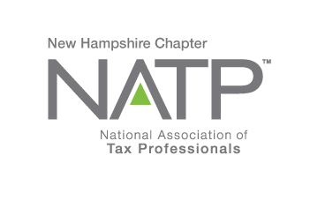
NH NATP FALL SEMINAR

WHEN: October 24, 2019 8:30 AM to 4:10 PM
WHERE: Holiday Inn, 172 No. Main St., Concord, NH
HOW: Education Packets will be delivered electronically to all attendees registered by October 21, 2019
COST: Before October 21, 2019: Members $135 Non-Members $150
After October 21, 2019: Members $155 Non-Members $170
Paper Materials $25 (request when registering online)

- CPE hours 5 different topics

Register online at https://natptax.com/Chapters/Pages/NewHampshireChapterEducation.aspx

By Mail: NATP, PO BOX 8002, Appleton, WI 54912

THE INSTRUCTOR………Helen O’Planick has taxes running in her blood! An EA since 1994, she is the managing member of HELJAN Associates LLC in Manchester, PA. Helen is a former member of ETAAC, and NAEA board member, and very active in the education field as a professional instructor. She has been featured on the Tax Talk Today with the IRS. Married 40 years this year to hubby Jim, they have two fantastic children and an amazing grandson. In her copious spare time, she is a gourmet jelly maker and loves to cook. Helen has addressed our group before and was an enormous hit!

THE TOPICS……..
SAVINGS BONDS – not just for saving money. We will look at ways to use savings bonds to maximize tax savings.
OUR GROWING E-CONOMY – let’s discover the way our clients are using tips and tricks for taxable and non-taxable income.
DEPRECIATION – we will explore all methods of depreciation, bonus depreciation, section 179 and when to take it or not.
TAX SAVINGS FOR OUR CLIENTS – let’s look at various ways we can save our clients their hard-earned dollars.

ALSO, Joe McCarthy, our new Senior Stakeholder Liaison, will be speaking on “The Next Data Breach Victim Could be You”. The discussion will include the costs associated with data breaches, common ways client data is stolen and ways to lower the risk of a data breach.

REGISTER TODAY! THIS WILL BE ANOTHER GREAT SEMINAR!

