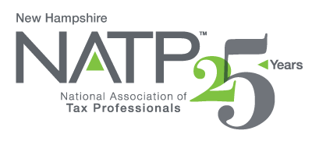
NH NATP SEMINAR

October 21, 2021

8:00 AM to 4:30 PM

Holiday Inn, 172 No. Main St., Concord, NH 03301

Melinda Garvin, EA and Jared Foos, EA will be the instructors. They are partners at Foos Garvin LLP in Ohio. Melinda has been an instructor for NATP for over 10 years, as well as the IRS Nationwide Tax Forum and various Ohio State organizations. Jared has co-presented at NATP seminars and the Ohio Fall Conference.

TOPICS:
- If Your Clients are Dying to See You – Estate filing
- Schedule K-1 (1065) and Basis
- Schedule K-1 (1120) and Basis
- Self-Employment Option – The Big Surprise
- D.I.V.O.R.C.E
- Top 10 Mistakes
- NH NATP Annual Meeting

8 CPE Credits

COST: Members $160 Early $175 Standard

Non-Members $175 Early $190 Standard

Early Registration ends October 14, 2021.

Cancellation deadline is October 14, 2021 - $30 fee is charged thereafter.

Materials will be provided electronically. Paper materials are $30.00.

Lunch will be provided.

Register online at https://natptax.com/Chapters/Pages/NewHampshireChapterEducation.aspx

By Mail: NATP, PO BOX 8002, Appleton, WI 54912

We hope to see you there!

