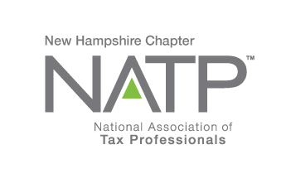
NH NATP FALL SEMINAR and ANNUAL MEETING

WHEN: October 26, 2017 8:30 AM to 3:30 PM
WHERE: Holiday Inn, 172 NO. Main St., Concord, NH
HOW: Education Packets will be delivered electronically to all attendees registered by October 20, 2017 (please notify Shirley Perry at sperry@mdccpas.com if you wish to purchase a printed copy for $25)
COST: Before October 20, 2017: Members $95 Non-Members $110
After October 20, 2017: Members $110 Non-Members $125

Register online at https://natptax.com/Chapters/Pages/NewHampshireChapterEducation.aspx

By Mail: NATP, PO BOX 8002, Appleton, WI 54912-8002

Topics:

IRS Security Summit Updates: Working in partnership with state tax agencies and the tax industry, the IRS has made significant progress against Identity Theft. This session will inform tax professionals of the actions taken by the Security Summit and provide information on new initiatives that targets various fraudulent schemes. Presented by Mary Hanson from the IRS.

Timber Taxes: This program will cover basic documentation and considerations in assessing federal income taxes from timber harvesting. Specifically, we will look at what constitutes a taxable gain, timber basis, timber depletion, a calculator that can help tax professionals determine if there is a financial benefit to depleting timber, and associated documentation. Presented by Andrew Fast, UNH.

Substantiation: Taxpayers are required to keep documentation to substantiate their expenses. The session will discuss what the documentation needs to include. The areas of business deductions like business travel and the “Cohen” rule will be covered, as well as documentation for charitable contributions. Presented by Lynn Annicchiarico, former President of NH NATP.

5 CE Credits

REGISTER TODAY !

