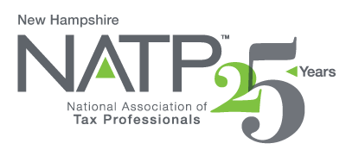
NH NATP FALL SEMINAR AND ANNUAL MEETING

WHEN: October 8, 2020 8:20 AM to 4:20 PM
October 9, 2020 8:30 Am to 12:20 PM

WHERE: Holiday Inn, 172 No. Main St., Concord, NH SAFE, SOCIAL-DISTANCING
HOW: Education Packets will be delivered electronically to all attendees registered by October 6, 2020
COST: Before September 9, 2020: Members $200 Non-Members $220
After September 8, 2020: Members $230 Non-Members $250
Paper Materials $25 (request when registering online)

11 CPE hours

Register online at https://natptax.com/Chapters/Pages/NewHampshireChapterEducation.aspx

By Mail: NATP, PO BOX 8002, Appleton, WI 54912

Once again, favorites, David and Mary Mellem of Ashwaubenon Tax Professionals of Green Bay, WI will be the instructors.

TOPICS:
DEBT CANCELLATION – examination of Forms 1099-C and 1099-A

LAWSUITS - Taxable Income? Deductible Legal Expenses?

OPENING A BUSINESS – Is it a Hobby? Business Structure? Recordkeeping?

CLOSING A BUSINESS – Inform who? When? Tax Consequences?

INHERITED PROPERTY – Basis of inherited assets? Special rules?

FEDERAL TAX UPDATE – New Legislation. Case law developments. Revenue rulings.

BANKRUPTCY – Laws and taxes. Discharges. Short years. Carryovers.

ETHICS – Issues of Circular 230. Recent cases.

REGISTER TODAY! THIS WILL BE ANOTHER GREAT SEMINAR!

